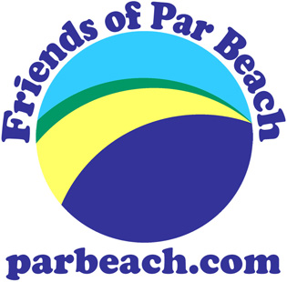Friends of Par Beach: Things to do!
Have a go at some of the following You don't need to do all of them to earn yourself a certificate. Get an adult to send your name (no need for surname), age, answers, words and pictures to gillbutler1@gmail.com (your email address will not be shared with anyone) the best ones will be put on our website (parbeach.com) They will appear on our Facebook page, and will also appear in the next edition of the PL24 Community Magazine.
You can find lots of information here:
- Go to https://www.usborne.com/quicklinks/eng/catalogue/catalogue.aspx?cat=1&area=NH&subcat=NC&id=614
PART 1
- What sort of grass grows on our sand dunes? Can you find a picture of it? Why is this grass so important?

- What other plants can you find on sand dunes, Name, draw and write a few words about some of them.

- Could you make a bird feeder? take a photo or do a drawing of your finished bird feeder

- Design a flag for par beach and its nature reserve. Here is an example.
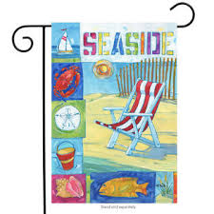

PART 2

- Why not try to write a short poem about the seaside? Here are 2 examples.

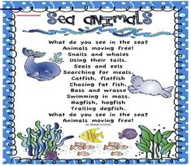

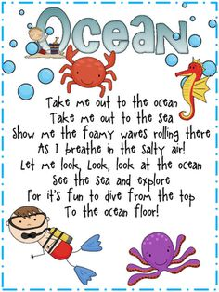

- Design a poster about what you can do about one of the following, plastic pollution, dog poo, respecting wildlife, feeding wildfowl etc.

- Tides; how many tides are there in 24 hours? Can you find out anything about them? Write a few words about them

- Find out about 5 different natural things that you would find at the seaside. Draw a picture of each one and write a few words about each one.

PART 3
- What birds can you find at the seaside. Name, draw and write a few words about three common ones.

- Who am I ? When you know what I am draw a picture of me and write a few words..
1. I live in a rock pool
I have lots of tentacles,
I use my tentacles to catch my food
If a creature gets too close I can sting it with my tentacles
When the tide goes out I can hide my tentacles in my body

2. Lots of us stick together on rocks
I have a hard shell
I look like a very tiny volcano
When the tide comes in, I wave my feathery legs out of the
hole at the top and catch my food
I am grey or white

3. I can be found in a rock pool
I am almost see-through
I have some short feelers and some long feelers
I have eyes on stalks
I have short legs under my body, they are like paddles
I can swim very fast
I have pincers on my front legs
I have a soft shell

4. I am an ocean animal
I can hunt for food
I have a beak
I lay eggs
I live in a 'den'
I have suckers
I can squirt ink
I can change colour
I have 8 'arms'

